**Download And Install WordPress On XAMPP and crate a post and publish.**

**WordPress:**

**WordPress** is a free and open-source content management system (CMS) based on PHP and MySQL. WordPress is installed on a web server that is either part of an Internet hosting service or a network host in its own right. The first case may be a service like WordPress.com, for example, and the second case could be a computer running the software package WordPress.org. A local computer may be used for single-user testing and learning purposes. Features include a plugin architecture and a template system. WordPress was used by more than 26.4% of the top 10 million websites as of April 2016. WordPress is reportedly the easiest and most popular website management or blogging system in use on the Web, supporting more than 60 million websites.

**Step-1:** download wordpress

**Step 2:** Search Wordpress

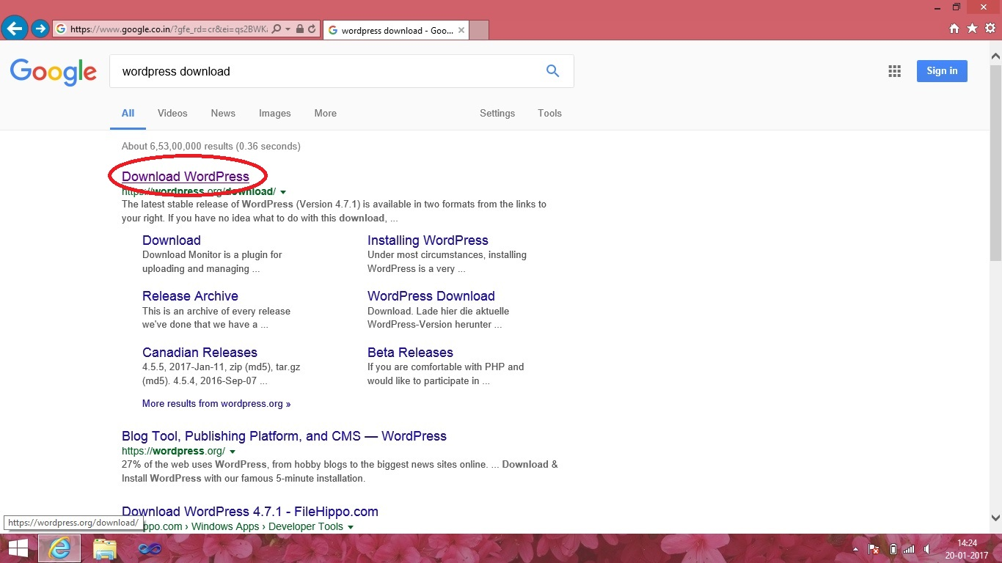

Here we have searched WORDPRESS for download and then click on any result to enter the website of WORDPRESS



**Step 3:** Download wordpress.

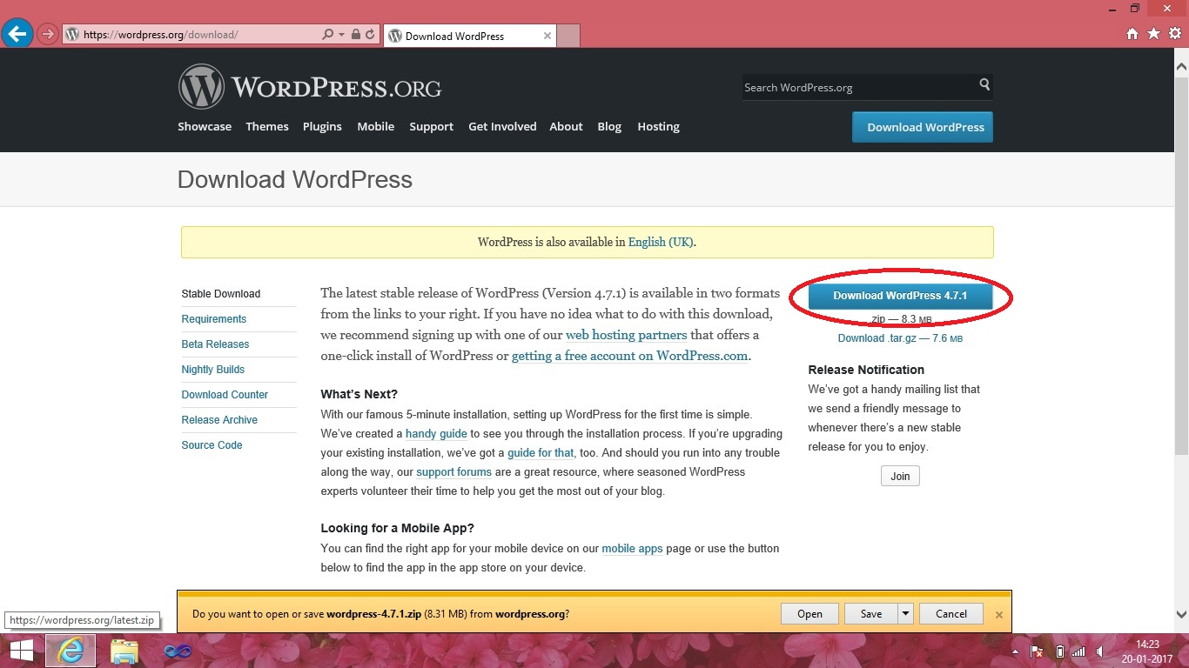

Click to download button and save the WORDPRESS zip file to your drive location where you want to store. After downloading extract the file.

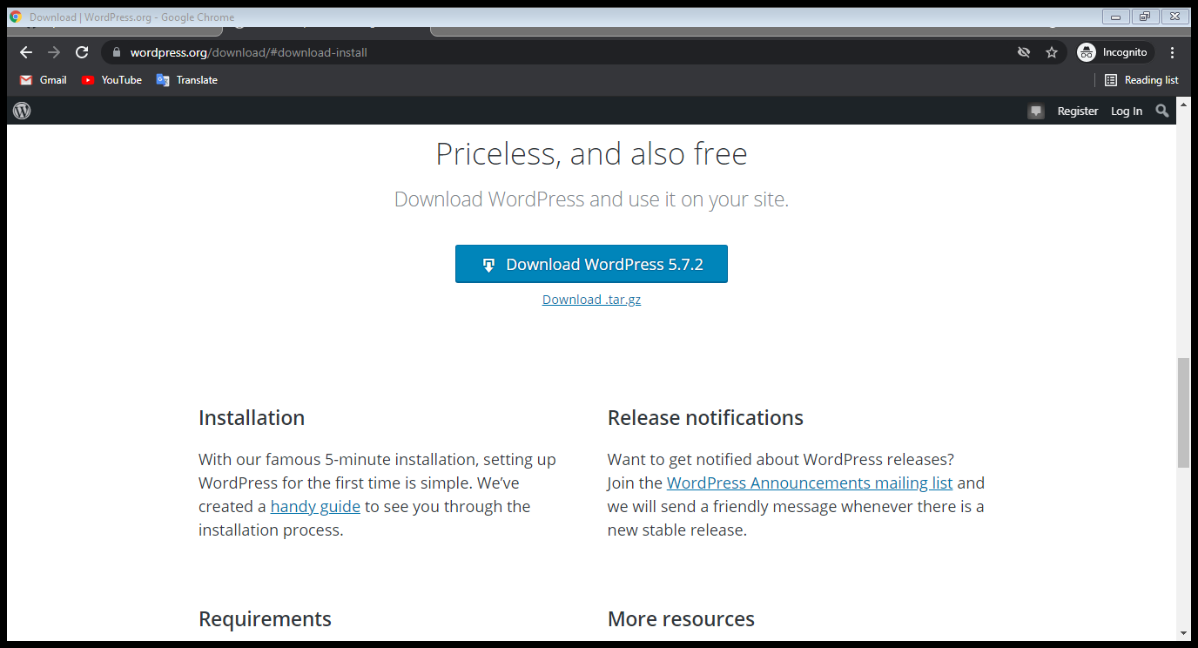

**Step 4:** copy the extracted file

After extracting the WORDPRESS files. Copy the WORDPRESS folder.

**Step 5:** open xampp control panel.

Start Apache server and then start MySQL database system.

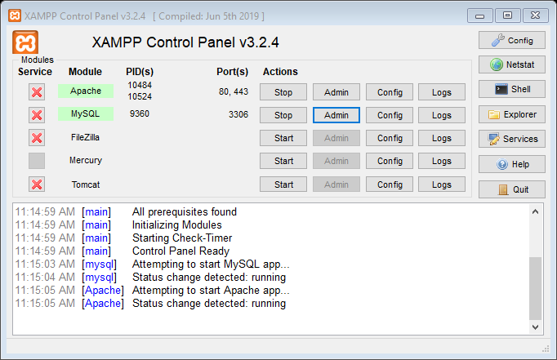

Then minimize the XAMPP control panel.

**Step 6:** open web browser

Type “localhost” on URL and then press enter button.

**Step 7:** XAMPP dashboard.

Then page will open of XAMPP dashboard. Click on to **“phpMyAdmin”**.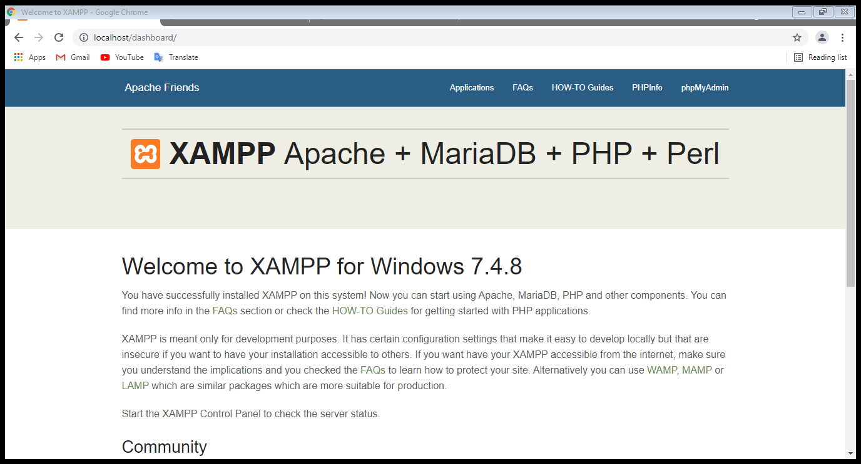

**Step 8:** create a database

The page “phpMyAdmin” will open. Click on **“Databases”** to create the database.

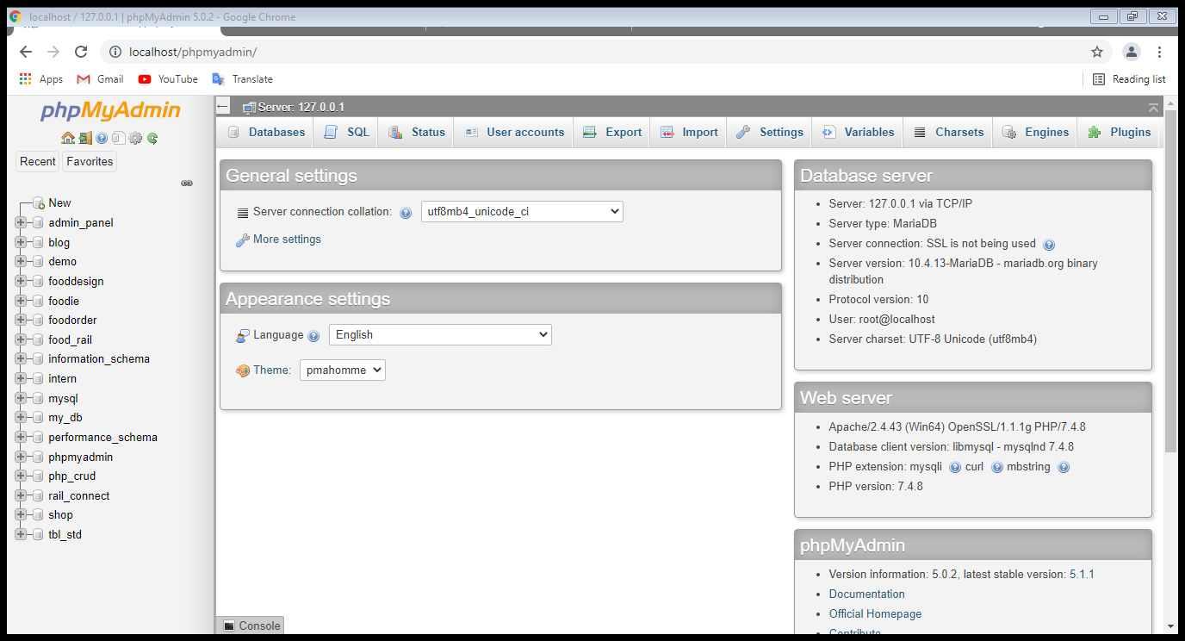

Click on to textbox to give database name. Here given name is **“MyNewDatabase”**. You can give any name as per your choice. And then click on **“create”** button to create your own database.

**Step 9:** paste WORDPRESS

After extracting the WORDPRESS file. Copy the WORDPRESS folder. Open C drive >> XAMPP folder. Paste the WORDPRESS folder into **“htdocs”** folder.

**Step 10:** open web browser.

Then switch to web-browser and type into URL **“localhost/wordpress”**

Click to enter button.

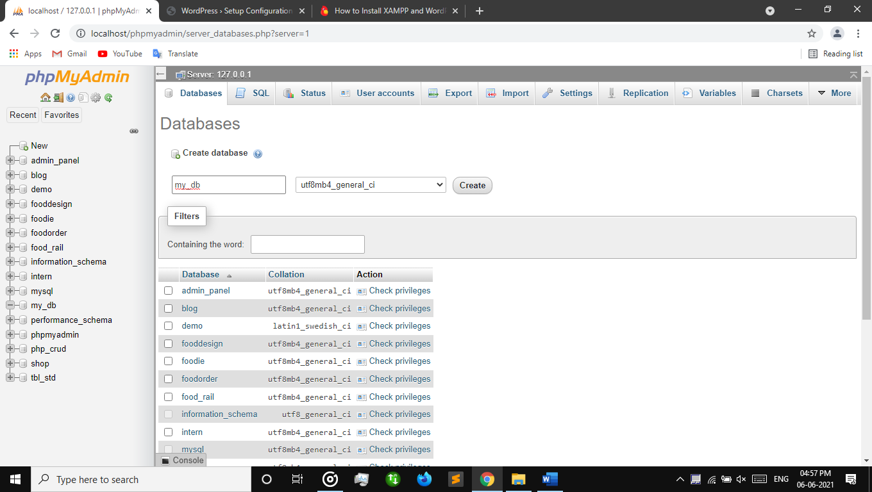

Here WORDPRESS will open. Click to **“Let’s go!”** button.

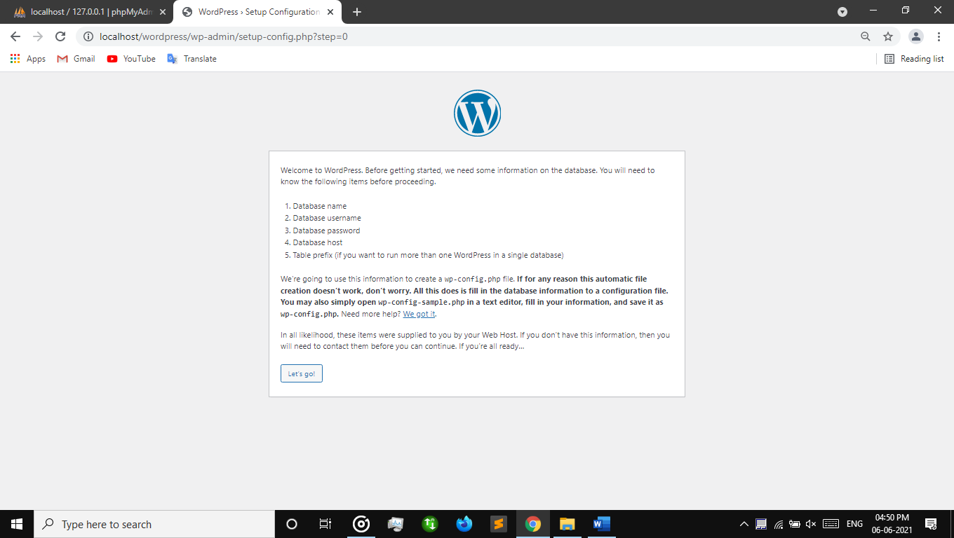

Here form will appear before you. Give database name where you created in “phpMyAdmin”. In this case the database name is **“MyNewDatabase”**. Type **“root”** into username. Do not provide any kind of password into password-box. Then click to **“submit”** button.

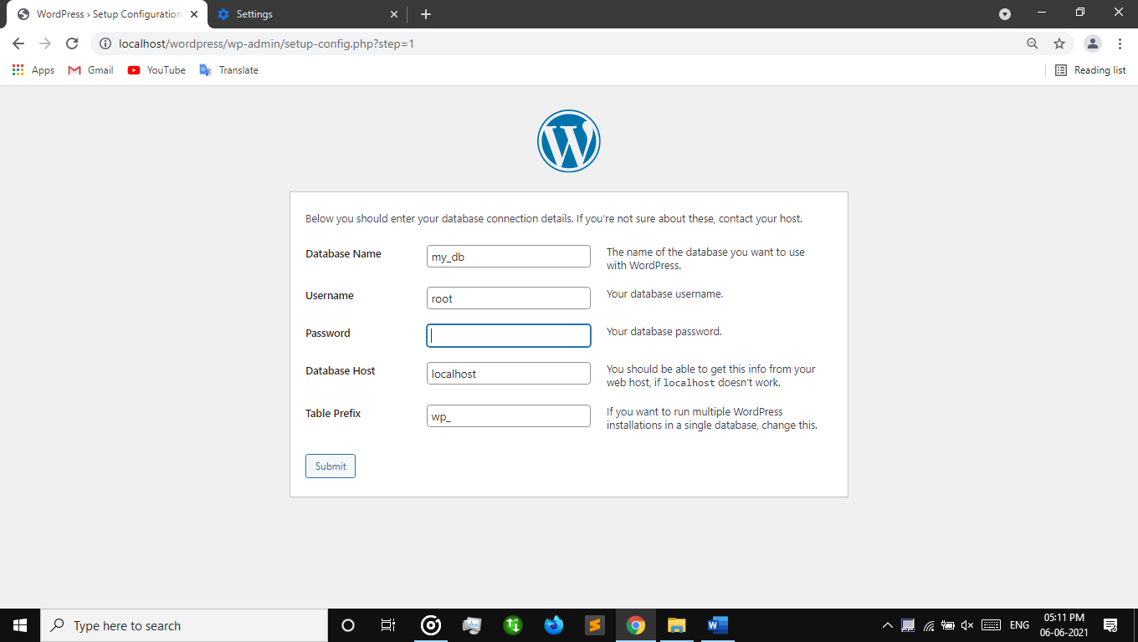

**Step 11:** **“Run the Install”**

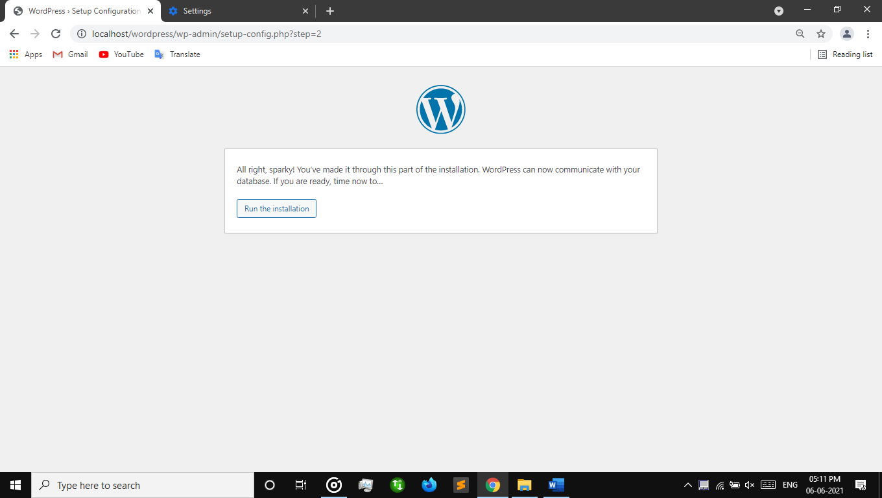

**Step 12:** sign in

Fill the necessary information in the boxes.

Here…

Site title:- MyFirstWeb

Username:- ram (give username what you prefer)

Password:- enter password for security

Confirm the checkbox

Fill your email address (it is compulsory)

Then hit on **“Install Wordpress”**

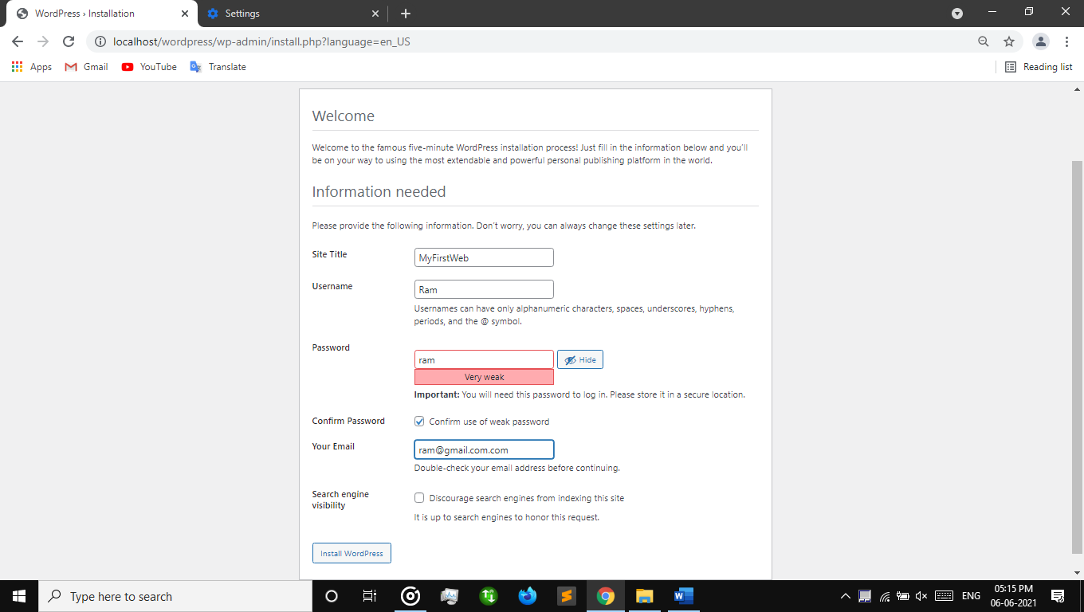

**Step 13:** Login

Give username and password

Press **“Log In”** button.

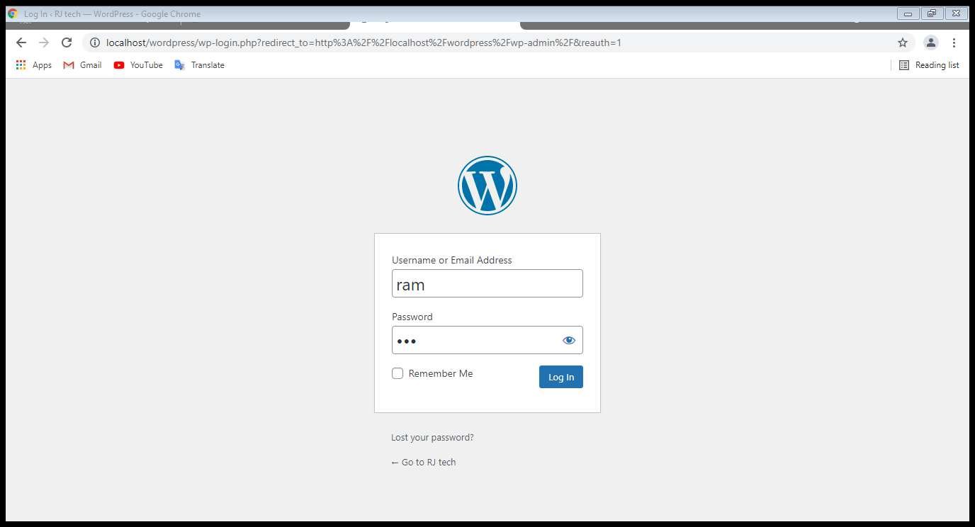

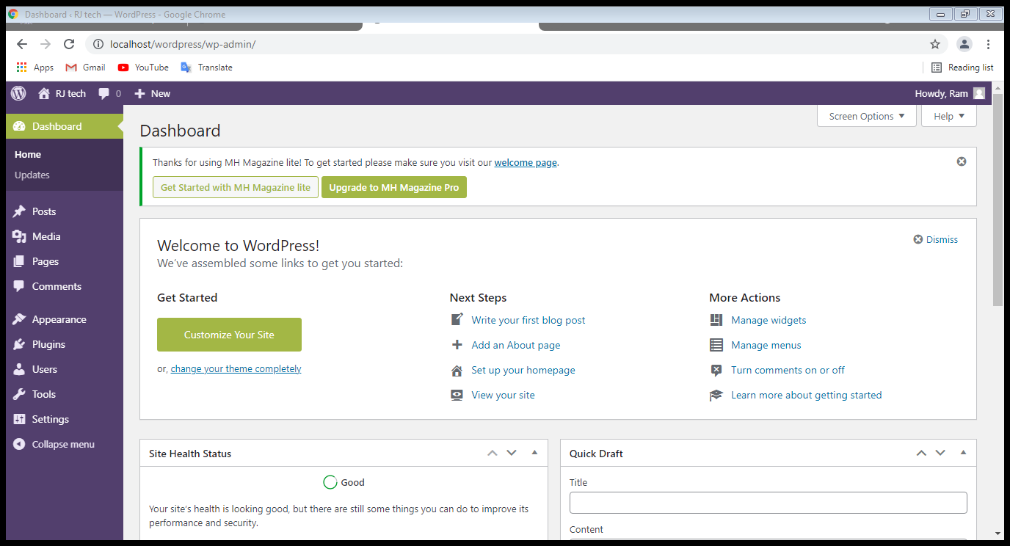

**End. . .**

**Post create and publish**

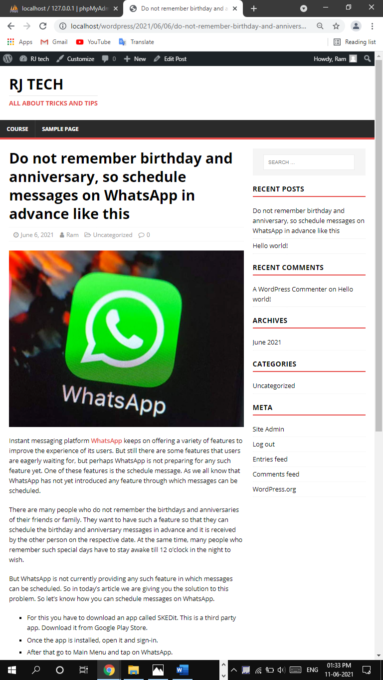

Post edit

